LADIES - 5 Hole Fun Day
4 Person AMBROSE

Golfers and Non-Golfers
(Golfers with a handicap over 36 can play as a non-golfer)
Maximum 2 Golfers each final team of 4 players

Sunday 22 February 2026
Tee Off 9am
Cost: $1 per hole

Nibbles sponsored by Ladies Captain
Allyson Sanewski

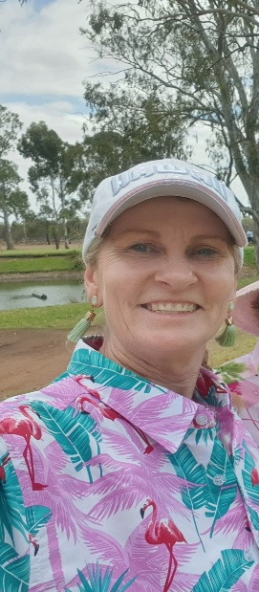

SHOTGUN TEE OFF 1st HOLE ON RED FROM 9.00 AM. PLAY HOLES 1, 6, 7, 8, 9. COME WITH A PLAYING PARTNER, GOLFER OR NON GOLFER. NON-GOLFERS GIVEN HANDICAP OF 36. DRAW FOR PARTNERS ON THE DAY. ARRIVE BY 8.30AM

CONDITIONS:-
1/16th Combined Handicap. Non Golfers Handicap 36.
Average Handicap of Group to be between 20 and 30.
1 Drive each Player. Players with handicaps of 36 plus are allowed 2 air swings per shot.

Normal 4 person ambrose rules apply.
Please put your team on our Facebook Page in order to help players know who is organized and who isn’t. Anyone requiring help to be part of a team register your interest on our page or personally on the sheet at the clubhouse and we will endeavor to organize you into a Team

